***This assignment must be hand-written.***

**Question 1 [CO1] : 20 Points**

Suppose that each of the following Update operations (a-j) is applied directly to the database state shown in Figure A2_1. **Consider each operation independent of each other. Each operation will be performed in the same state of Figure A2_1.** Discuss all integrity constraints violated by each operation (check Figure A2_2 for Referential integrity constraints on the database of Figure A2_1), if any, and the different ways of enforcing these constraints.

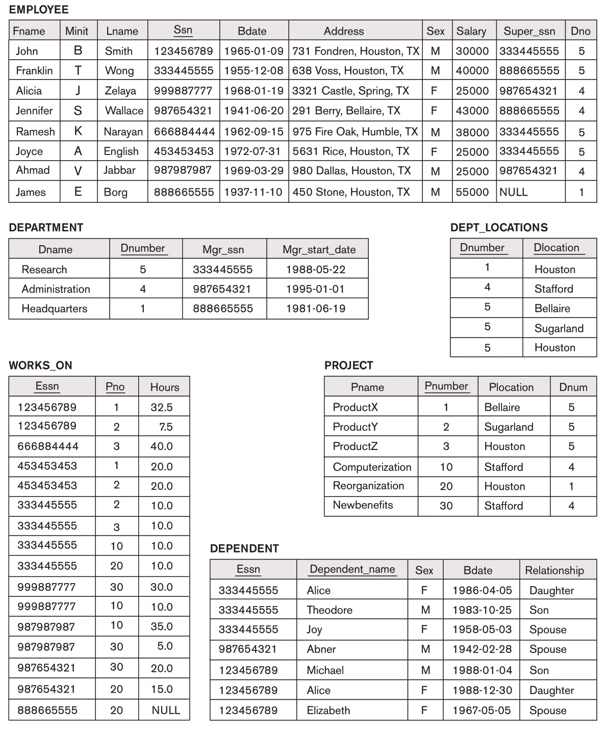

Figure A2_1 : COMPANY database.

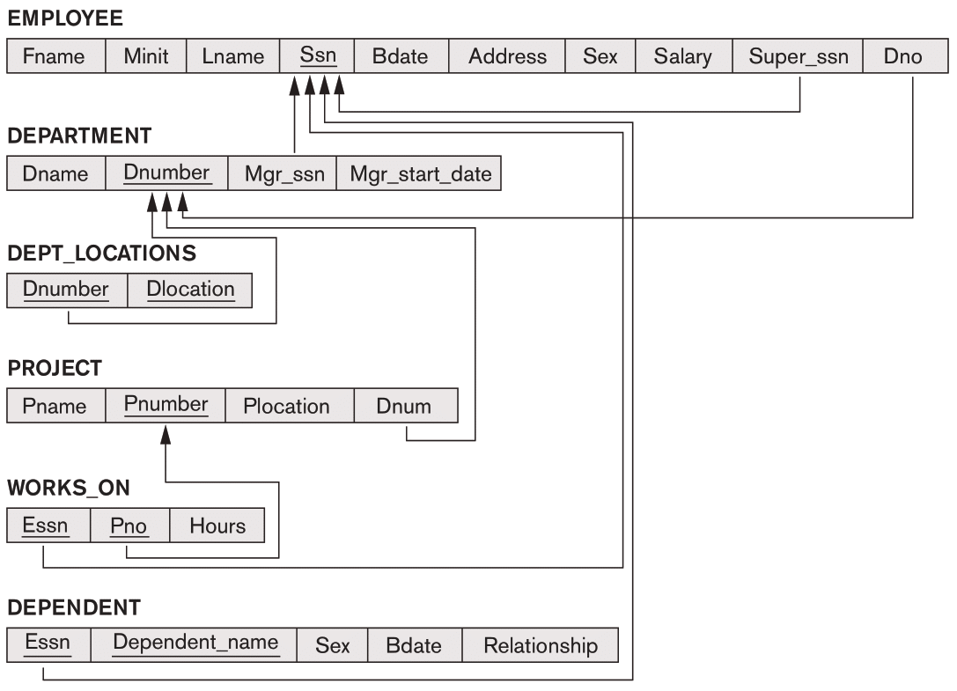

Figure A2_2 : Referential integrity constraints on the COMPANY database of Figure A2_1.

Write if **(i)** any of the following operations violates any integrity constraints and **(ii)** if violated, how those constraints can be enforced.

1. Modify the Bdate attribute of the DEPENDENT tuple with Essn= '123456789' and Dependent_name= 'Alice' to '1988-12-28'.
2. Insert <'Ghost', 4, 'Mohakhali', 3> into PROJECT.
3. Insert <'Procurement', 1, '123456780', '2007-10-01'> into DEPARTMENT.
4. Insert <NULL, '13', '40.0'> into WORKS_ON.
5. Insert <'999887777', '30', 5.0> into WORKS_ON.
6. Delete the EMPLOYEE tuple with Ssn = '987654321'.
7. Delete the WORKS_ON tuples with Essn = '333445555'.
8. Modify the Super_ssn attribute of the EMPLOYEE tuple with Ssn = '453453453' to '987987998'.
9. Delete the PROJECT tuple with Pname = 'Reorganization'.
10. Modify the Mgr_ssn and Mgr_start_date of the DEPARTMENT tuple with Dnumber = 1 to '999887777' and '2023-10-23', respectively.